POLAR Demonstration Cases using PHOENICS-3.6.2

This report describes two demonstration cases of the new PHOENICS-3.6.2 feature “POLAR PARSOL.”

CASE 1. Butterfly Valve: POLAR PARSOL

A Butterfly Valve in a pipe is a typical POLAR case for CFD applications. The flow rate through the pipe is controlled by the rotation angle of the valve. Control engineers need to know how sensitive the flow rate is to fluid pressure and valve angle changes and the consequential implication for hydraulic loss.

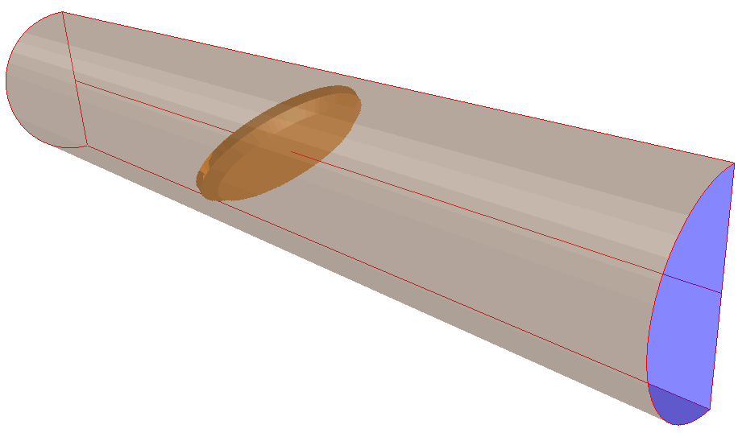The demonstration case uses a 40mm diameter of 4mm thickness. The pipe length is 200mm. Half of the symmetrical pipe domain was simulated; the geometry and domain are shown in Figure 1.

Five runs were carried out with different valve openings (with angle 0º fully closed and 90º fully open). The relative working pressure used is 50 [Pa] at the inlet and zero at the outlet.
Figure 1. Geometry model of butterfly valve

The results, shown in Figure 2, give the relationship between valve angle, total loss coefficient and flow rate. Under the circumstance defined for this case, the total loss coefficient is high with a small valve opening, and decreases by nearly 90% during the first 45º opening. Correspondingly, the flow rate is almost linearly increased below 50º, before slowly increasing at even wider apertures.

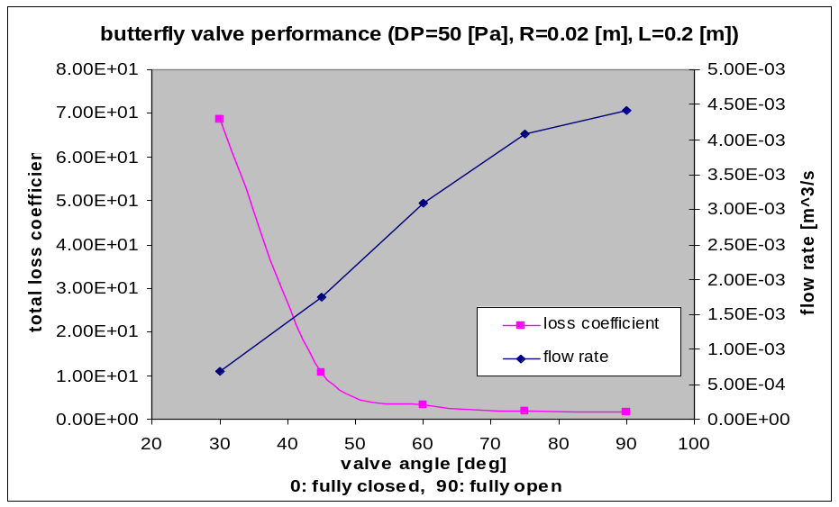
Figure 2. Performance curve of butterfly valve

Velocity contours with a 45º opening in Figure 3 show the incoming stream deflected by the valve. The highest velocity 0.53 [m/s] at the bottom opening results in jet flow and fluids through the top gap spreading along the whole pipe section, as expected. Streamlines of residence time in Figure 4 show the same flow pattern.

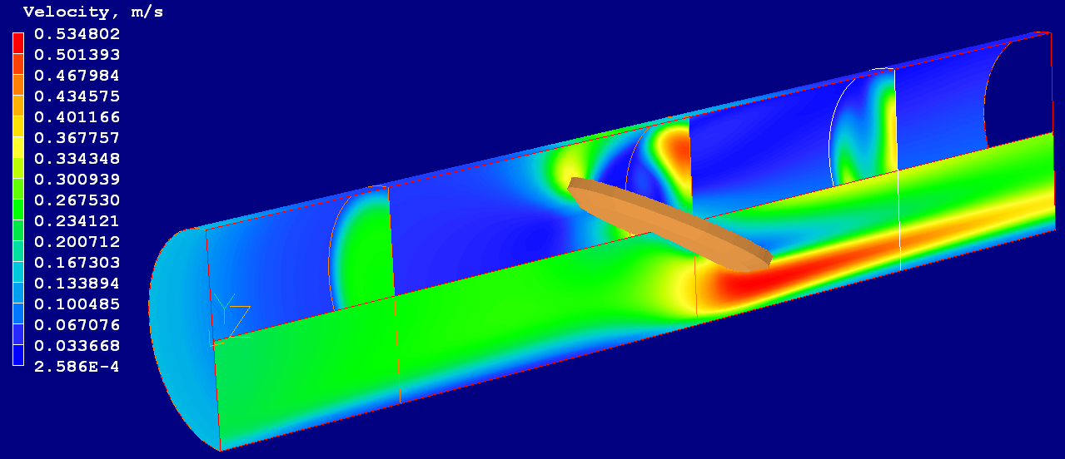
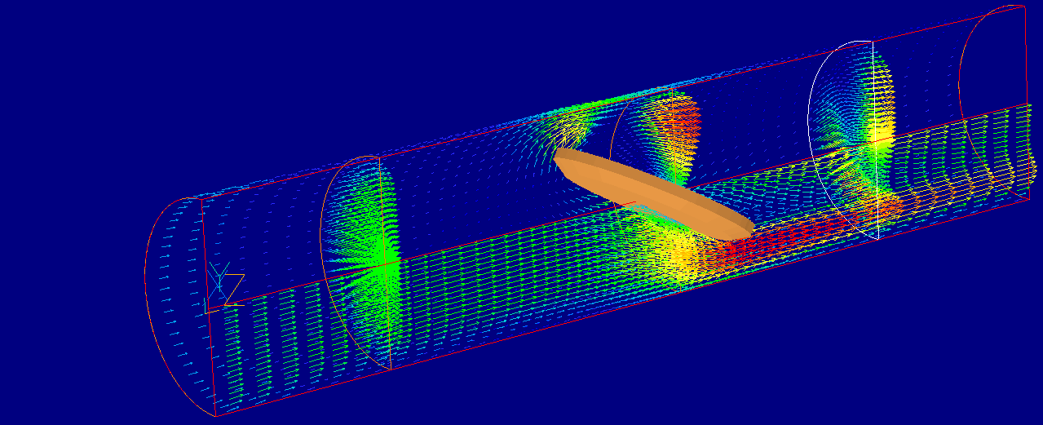

Figure 3. Velocity solution of the solution at 45º valve opening

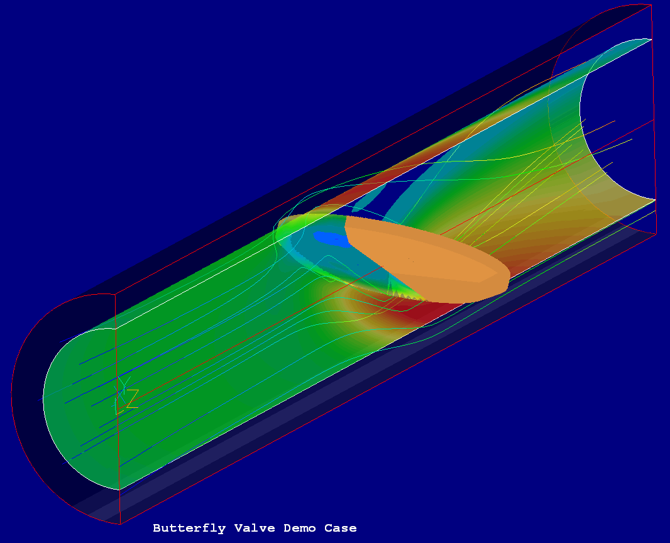

Figure 4. Streamlines of residence time at 45º valve opening

The simulation demonstrates that the POLAR PARSOL feature is a useful tool for valve designers to predict the valve performance to achieve optimal design, and allows control engineers to analyse and improve the behaviour of valves under differing operational circumstances. Click here to view an animation.

CASE 2. Poppet Valve: POLAR PARSOL + MOFOR

The poppet valve motion in an internal combustion engine is of particular importance to design engineers, and has been widely studied. This example demonstrates the ease-of-use of the new “POLAR PARSOL” feature in PHOENICS when combined with MOFOR.

The poppet valve geometry, shown in grey in Figure 5, moves up and down periodically in the centre of a seat ring, shown in blue. The inlet is on the surface of the seat ring, and the entire base is an outlet. In this simulation, the diameters of the valve head: are 40mm, the valve stem: 12mm, the chamber: 50mm, and height 80mm.

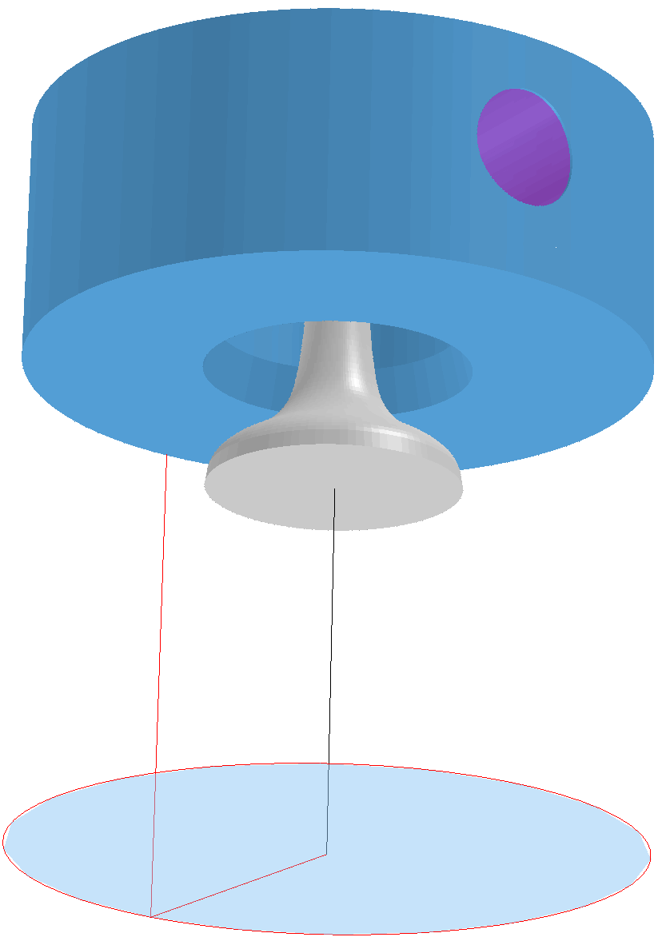
Figure 5. Geometry model of poppet valve

The simulation was run for 0.04 [s] in 10 time steps. The motion of the valve in the axial direction is linear, within a distance of 22 [mm]. Results at the sixth time step are provided.

Figure 6 shows the fluid coming from the side inlet on the seat ring then being pushed out through the gap between valve head and seat ring. Weak circulation occurs in the chamber just below the seat ring. The main flow stream moves straight towards the outlet, as shown in Figure 7. The scalar tracer in Figure 8 shows the same flow pattern.
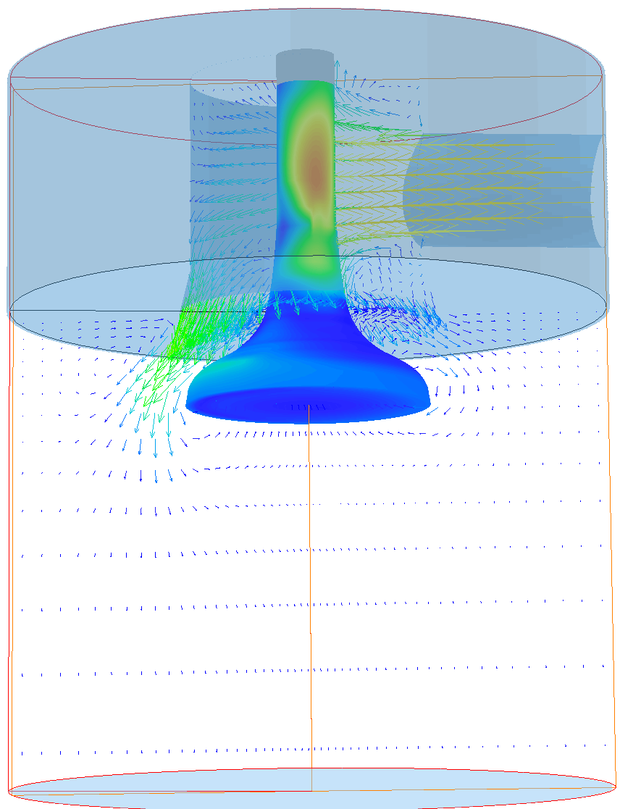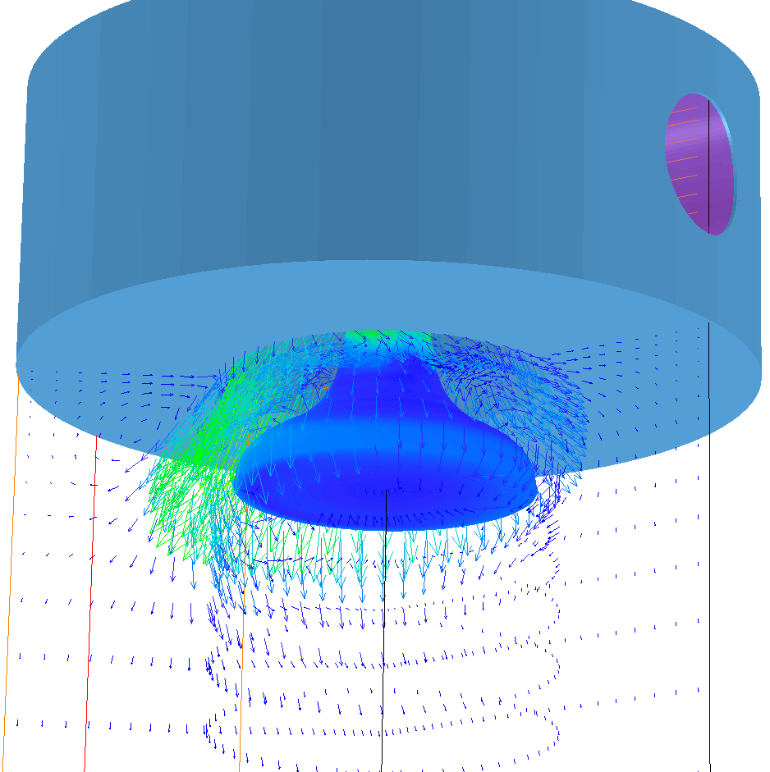

Figure 6. Velocity vectors at X-plane through the inlet and Y-plane around the valve head (left) and enlarged view (right) at sixth time step

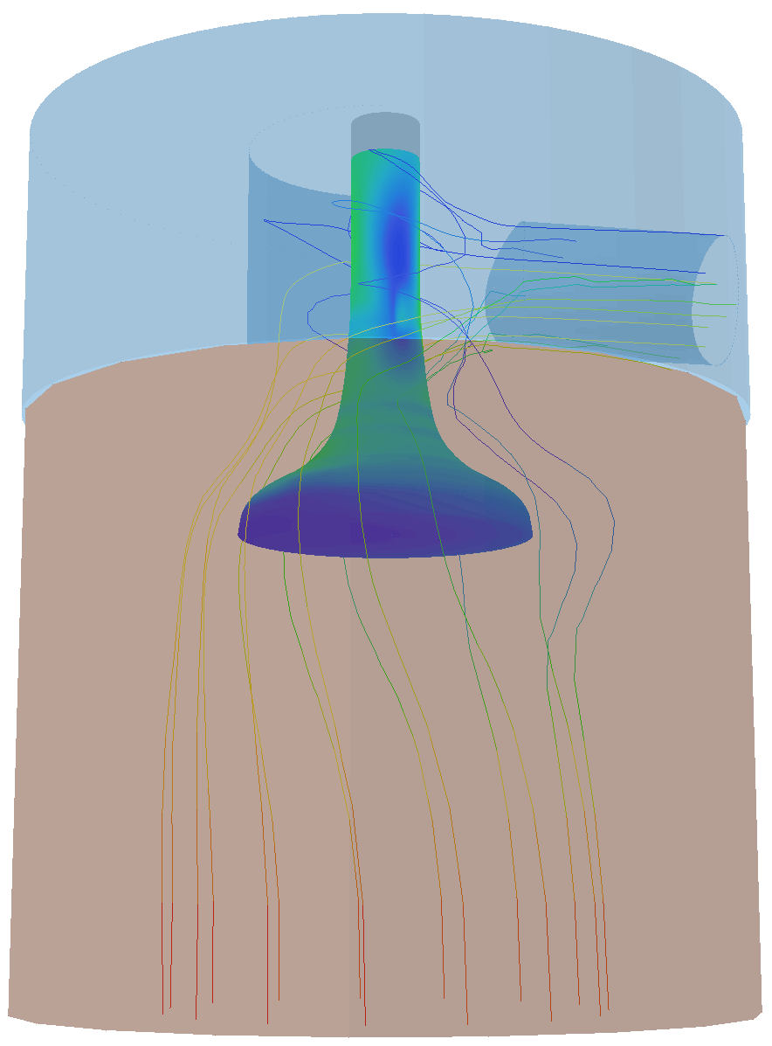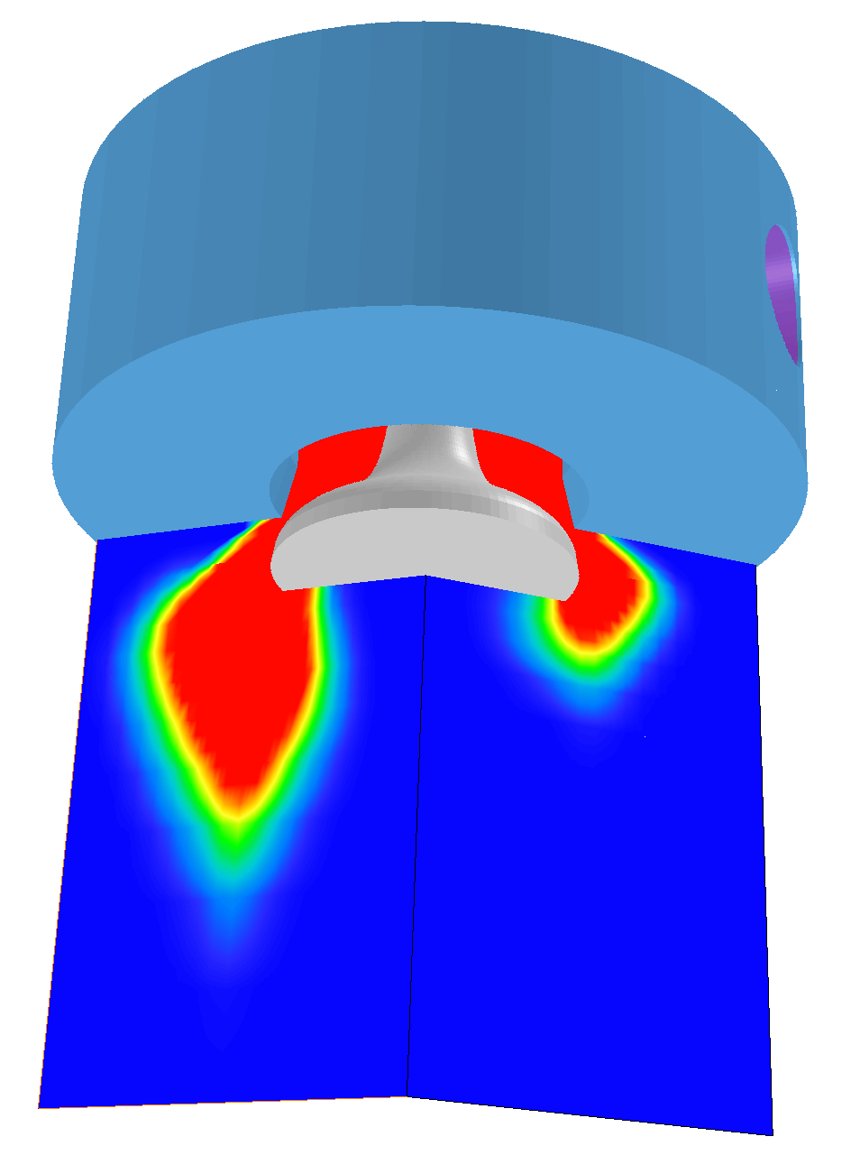
Figure 7. Streamlines of residence time Figure 8. Scalar tracer in the fluid flow

The example demonstrates that the combination of POLAR PARSOL and MOFOR can help the design engineer analyse fluid flow scenarios to optimise valve design or control parameters. Click here to view an animation.

